Radiation Hazards and the Roles of Melanin and Lactate in Radioprotection and Intestinal Epithelial Repair

Abstract
Radiation is widely present in the natural environment, medical imaging, radiotherapy, and industrial production. When used appropriately and under established standards, radiation provides major benefits for disease diagnosis and treatment. Exposure beyond the body's tolerance, however, can directly damage DNA and generate reactive oxygen species, causing cell death, tissue inflammation, and a higher long-term risk of cancer. The intestinal epithelium renews rapidly, and stem cells at the base of the intestinal crypts divide continuously, making it one of the tissues most sensitive to ionizing radiation. In recent years, the potential roles of melanin and lactate in radioprotection and tissue repair have attracted growing interest. Melanin can absorb part of the incident electromagnetic energy and scavenge free radicals, and it has shown some radioprotective capacity in fungal and animal studies. Lactate is not merely a metabolic by-product; it can also act as an energy substrate and signaling molecule. Through Paneth cells, the GPR81 receptor, and the Wnt/beta-catenin pathway, lactate may promote intestinal stem-cell proliferation and epithelial reconstruction. Most current evidence, however, comes from cell, organoid, and animal studies and does not justify self-administration of melanin, lactate, or probiotics to prevent radiation injury. Sound radiation protection should continue to focus on limiting exposure time, increasing distance, using appropriate shielding, and seeking standard medical care.
Keywords
radiation injury; melanin; lactate; intestinal epithelium; intestinal stem cells; tissue repair

1 Radiation Hazards and Intestinal Injury

Radiation is energy transmitted as electromagnetic waves or particles. It is generally classified as non-ionizing or ionizing radiation according to whether it has enough energy to ionize atoms or molecules. Visible light, radio waves, and most ultraviolet radiation encountered in daily life are non-ionizing, whereas X-rays, gamma rays, and some high-energy particles are ionizing. Ultraviolet radiation mainly injures the skin and eyes: excessive short-term exposure can cause sunburn and keratitis, while cumulative exposure is associated with skin aging, cataracts, and skin cancer [1]. Ionizing radiation carries more energy. It can directly cause single- or double-strand DNA breaks, or radiolyze intracellular water to generate reactive oxygen species such as hydroxyl radicals, which then damage proteins, lipids, and genetic material [2].

Public discussions often mix together very different forms of radiation. Mobile-phone signals, microwave ovens, and nuclear-medicine examinations all involve energy transfer, but their frequencies, energies, and interactions with human tissue are fundamentally different. The ability to cause ionization is an important boundary when biological risk is assessed. Non-ionizing radiation is not automatically harmless, because intense ultraviolet radiation or high-intensity thermal radiation can still cause injury. Conversely, ionizing radiation does not mean that a single exposure will inevitably cause disease. A meaningful risk assessment must consider the type of radiation, dose, irradiated area, and duration of exposure rather than simply asking whether radiation is present.

Radiation is described using several units, including the becquerel, gray, and sievert. The becquerel measures how many radioactive decays occur each second and therefore describes the activity of a source. The gray measures the amount of radiation energy absorbed per unit mass of tissue. The sievert additionally accounts for radiation type and the sensitivity of different organs, providing an estimate of possible health effects in humans. These units answer different questions and are not interchangeable. A news report that gives only a number, without a unit, the exposed body region, or the exposure duration, usually provides too little information to judge the actual risk.

The effects of radiation on the body are not determined simply by whether exposure occurred. They also depend on absorbed dose, dose rate, radiation type, exposed region, exposure duration, and age. Low doses or doses spread over a longer period usually do not cause obvious acute symptoms, although radiation-protection principles still apply. A high whole-body dose delivered over a short period can cause skin injury, bone-marrow suppression, and acute radiation syndrome. Children, adolescents, and rapidly developing tissues are generally more sensitive [2].

Radiation effects can be broadly divided into tissue reactions and stochastic effects. Tissue reactions usually become apparent only after the dose reaches a certain range; examples include skin erythema, hair loss, lens injury, and bone-marrow suppression, with severity generally increasing as dose rises. Stochastic effects mainly refer to long-term risks such as cancer. They do not occur in every exposed person, but their probability may increase with cumulative dose. This distinction helps explain why a low-dose examination usually does not produce visible acute injury, while the principles of clinical justification and keeping dose as low as reasonably achievable still remain important.

Human tissues also differ in radiosensitivity. Rapidly renewing cells, including bone-marrow hematopoietic cells, intestinal crypt cells, and germ cells, tend to be more sensitive to ionizing radiation. Mature neurons and muscle cells divide less often and are comparatively resistant to acute cell killing, although this does not make them immune to injury. The irradiated volume is equally important: localized exposure to a small region and high-dose whole-body irradiation have fundamentally different consequences. For this reason, medical imaging, localized radiotherapy, and major radiation accidents cannot be compared without considering their distinct contexts.

The small-intestinal epithelium is one of the fastest-renewing tissues in the body and is usually replaced every four to five days [3]. Lgr5-positive intestinal stem cells at the base of the crypt divide continuously, producing absorptive epithelial cells, mucus-secreting goblet cells, and antimicrobial Paneth cells. Because rapidly dividing cells are especially vulnerable to DNA damage, high-dose ionizing radiation can trigger intestinal stem-cell apoptosis, crypt atrophy, villus shortening, and disruption of intercellular tight junctions. When the mucosal barrier develops gaps, water and electrolyte absorption is impaired, and bacteria or bacterial products from the intestinal lumen may enter tissue and blood, potentially causing severe diarrhea, dehydration, infection, and systemic inflammation [4].

The normal intestinal barrier is not a static wall. It is a dynamic system formed by the mucus layer, epithelial cells, intercellular tight junctions, immune cells, and the intestinal microbiota. Mucus from goblet cells reduces direct contact between bacteria and the epithelium. Paneth cells produce antimicrobial peptides, tight-junction proteins restrict harmful substances from passing between cells, and immune cells in the lamina propria recognize and eliminate pathogens that cross the barrier. Ionizing radiation can affect all of these components at once. Radiation-induced intestinal injury is therefore not simply the loss of a surface layer of cells; it involves a continuing series of changes in barrier function, immunity, microcirculation, and microbial ecology.

Repair after intestinal injury usually requires several coordinated stages. Damaged or irreparable cells are first removed while inflammatory and stress signals rise rapidly. Surviving intestinal stem cells and some plastic progenitor cells then enter a proliferative state and expand new cell populations. Finally, newly generated cells migrate, differentiate, and rebuild villus architecture and tight junctions. Failure at any stage can lead to persistent mucosal atrophy, malabsorption, or chronic inflammation. Because repair is complex, a single antioxidant or metabolite is rarely sufficient to reverse severe injury completely.

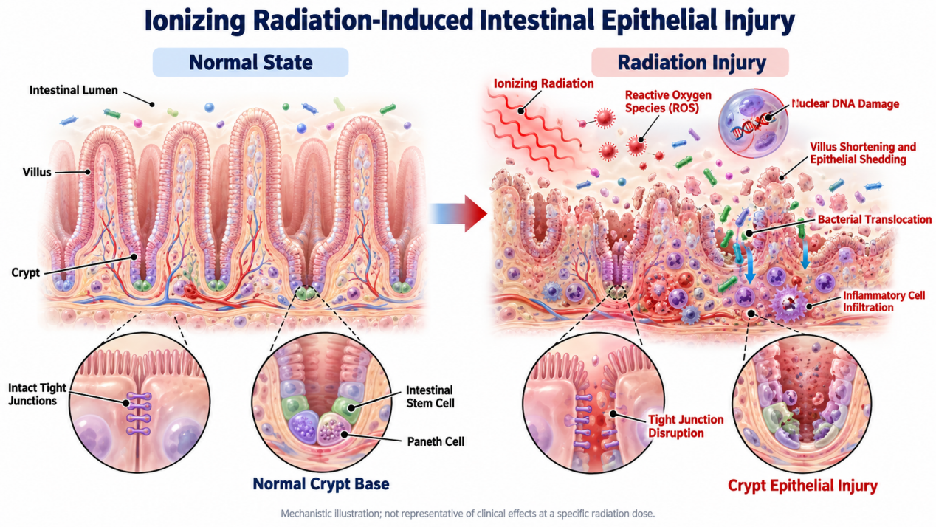
Figure 1. Ionizing radiation-induced intestinal epithelial injury. The left side shows intact villi, the crypt stem-cell compartment, and tight junctions. The right side shows radiation-induced DNA damage and reactive oxygen species, followed by crypt-cell loss, villus disruption, inflammatory-cell infiltration, and bacterial passage across the damaged barrier. This is a mechanistic illustration and does not represent the clinical effects of any specific radiation dose.

Radiation injury also has a distinct time course. Damaged cells may be successfully repaired or may die. If a cell continues to divide after erroneous DNA repair, the long-term risk of tumor formation may increase. Radiation protection therefore has two complementary goals: minimizing unnecessary dose before and during exposure, and supporting the repair of normal tissue afterward. Melanin and lactate broadly represent these two directions. Melanin is associated more closely with energy absorption and reduced oxidative injury, whereas lactate is associated more closely with supporting stem cells and rebuilding the epithelium.

2 The Radioprotective Potential of Melanin

Melanin is a structurally complex family of natural macromolecular pigments. In human skin, it is produced mainly by melanocytes. Eumelanin is generally brown to black, absorbs light over a broad wavelength range, and releases part of that energy as heat. It can also scavenge free radicals and bind certain metal ions. Increased melanin production after ultraviolet exposure is an adaptive response that limits further damage, but a tan itself is evidence that ultraviolet injury has already occurred. The World Health Organization notes that an ultraviolet-induced tan provides only very limited additional protection and does not prevent long-term harms such as skin cancer [1]. Deliberately tanning to increase melanin is therefore not a safe method of radiation protection.

Human melanin is not a single substance. Eumelanin generally has strong light-absorption and antioxidant properties, whereas yellow-red pheomelanin can participate in different oxidative reactions under some conditions. Melanins from different sources vary greatly in chemical composition, particle size, hydration, and spatial arrangement, all of which influence their interactions with radiation and free radicals. Fungal melanin, synthetic polydopamine-like materials, and melanin in human skin therefore cannot be treated as identical materials.

Melanin's role in ultraviolet protection is relatively easy to understand: located around cells in the superficial skin, it absorbs some ultraviolet radiation and reduces the energy reaching DNA. The situation is far more complex for penetrating X-rays and gamma rays. Small amounts of melanin cannot provide reliable engineering shielding in the way that an adequate thickness of lead, concrete, or water can. Researchers are instead asking whether melanin, when formulated as a high-density material, arranged appropriately within a composite, or positioned near tissue that needs protection, can reduce injury through a combination of energy attenuation and free-radical scavenging.

Interest in melanin's interactions with ionizing radiation first grew from observations in microorganisms. Some heavily melanized fungi can live in high-radiation environments. Compared with corresponding strains that lack melanin, melanized fungi often survive X-rays, gamma rays, or high-energy particles at higher rates. Possible mechanisms include absorbing or scattering part of the radiation energy, stabilizing free radicals, reducing attacks by reactive oxygen species on cell membranes and DNA, and dispersing local energy through distinctive spatial organization [5-6].

These fungal studies are informative because researchers can compare melanized strains with melanin-deficient mutants of the same species, minimizing the influence of other genetic differences. In some experiments, irradiation also alters melanin's electronic structure and redox properties, and melanized cells show greater metabolic activity in high-radiation environments. This does not mean that fungi efficiently feed on radiation in the way plants use sunlight. The proposed mechanisms of energy transduction remain debated and cannot be extrapolated directly to humans.

Animal studies provide preliminary evidence as well. In one mouse study, an edible mushroom material containing melanin was administered orally before whole-body irradiation. Treated mice showed less apoptosis in intestinal crypts, faster recovery of cell proliferation, and improved survival [7]. The material, dose, and timing were tightly controlled, however, so the findings cannot be translated into the claim that eating more dark-colored foods protects against nuclear radiation. Food color does not indicate the presence of a radioprotective component that the body can use effectively. Black sesame seeds, black beans, and wood-ear mushrooms cannot replace lead shielding, dose control, or professional medical care.

From a translational perspective, animal findings must answer several additional questions. Is melanin stable in the digestive tract, can it reach the intended site, and can it remain there at an adequate concentration? Could long-term or high-dose use alter nutrient absorption, drug metabolism, or the gut microbiota? Could binding to metal ions or drug molecules create new toxicities? Radiotherapy must kill tumor cells; a systemic protectant that also shields the tumor could weaken treatment. A melanin-based product intended for radiotherapy would therefore need to protect normal tissue locally, briefly, and selectively.

Melanin also does not shield every form of radiation equally. Experiments comparing the attenuation of beta radiation by melanin and cellulose materials have not always shown a clear advantage for melanin [8]. Its potential value may therefore arise not only from physically blocking radiation but also from free-radical scavenging, chemical composition, and material structure. More promising future applications may include melanin composites, local protective coatings, or drug carriers targeted to normal tissue rather than unverified oral supplements.

3 Lactate and Intestinal Epithelial Repair

Lactate was once regarded simply as a waste product of anaerobic metabolism. It is now understood to serve both as an energy substrate and as an important cellular signal. At the base of the intestinal crypt, Paneth cells lie next to Lgr5-positive intestinal stem cells but use different metabolic programs. Paneth cells preferentially produce lactate through glycolysis, whereas intestinal stem cells can take up lactate and convert it to pyruvate for mitochondrial oxidative metabolism. Animal and organoid studies suggest that this metabolic cooperation helps maintain intestinal stem-cell function, cell differentiation, and crypt homeostasis [3].

This discovery changed the traditional view of lactate as merely a metabolic endpoint. In many tissues, lactate forms a metabolic shuttle: one cell releases it and another takes it up for renewed use in energy metabolism. In the intestinal crypt, division of labor between Paneth cells and stem cells supplies stable substrates in a rapidly renewing environment. Moderate amounts of reactive oxygen species are not entirely harmful in this setting; they can also participate in intracellular signaling. Outcome depends on where they are produced, at what concentration, and for how long. The large, uncontrolled oxidative stress caused by radiation damages cells, whereas brief, controlled oxidative signals during metabolism may help direct differentiation.

Lactate can also be produced by commensal microorganisms such as Lactobacillus and Bifidobacterium. Microbiota-derived lactate can reach the crypt region and bind to GPR81, a G-protein-coupled receptor on Paneth cells and intestinal stromal cells. Activation of GPR81 promotes Wnt release, which then activates the Wnt/beta-catenin pathway in nearby intestinal stem cells and drives stem-cell proliferation and epithelial-cell production [9]. In simple terms, lactate may do more than provide fuel for repair: it may also signal the stem-cell microenvironment to begin rebuilding.

The Wnt/beta-catenin pathway is a central signaling network that maintains intestinal stem-cell identity and proliferative capacity. Under normal conditions, Paneth cells, stromal cells, and other components of the crypt microenvironment jointly regulate Wnt signaling, allowing stem cells to generate new cells without proliferating uncontrollably. By promoting Wnt-related signals through GPR81, lactate modulates the niche in which stem cells reside. Lactate does not itself become new epithelium; rather, it changes signaling from surrounding cells and helps create conditions in which stem cells can initiate repair.

The intestinal microbiota may have both beneficial and harmful roles in this process. Appropriate commensal organisms and their metabolites support mucosal homeostasis, but radiation can alter the intestinal environment, reducing some beneficial organisms and increasing opportunistic pathogens. Once the barrier is disrupted, even normally harmless bacteria may enter tissue and cause infection. Using live microbial preparations to repair radiation-induced intestinal injury therefore presents a practical dilemma: they may supply useful metabolites, yet they may also create infection risk when immunity is suppressed and the barrier is severely damaged. Future approaches may favor defined strains, inactivated organisms, purified metabolites, or delivery systems that release signaling molecules locally.

In mouse experiments, lactate-producing commensal bacteria or defined doses of lactate increased the numbers of intestinal stem cells, Paneth cells, and goblet cells. Related treatment before irradiation or chemotherapy also reduced subsequent epithelial injury to some extent. Mice lacking GPR81 did not receive the same degree of protection, indicating that lactate acts at least partly through GPR81 signaling [9]. Other research found that microbiota-derived lactate accelerated colonic epithelial turnover under specific conditions, although excessive proliferation also shows that its effects depend strongly on context [10].

These studies show mainly that lactate participates in intestinal development and repair; they do not show that any dose of lactate can treat established, severe radiation enteritis. Preventive administration and post-injury therapy are different questions. Maintaining stem-cell status before irradiation may improve tissue tolerance, whereas administering lactate after exposure must contend with altered receptor expression, impaired microcirculation, dysbiosis, and too few surviving stem cells. Different stages may require entirely different doses and intervention windows.

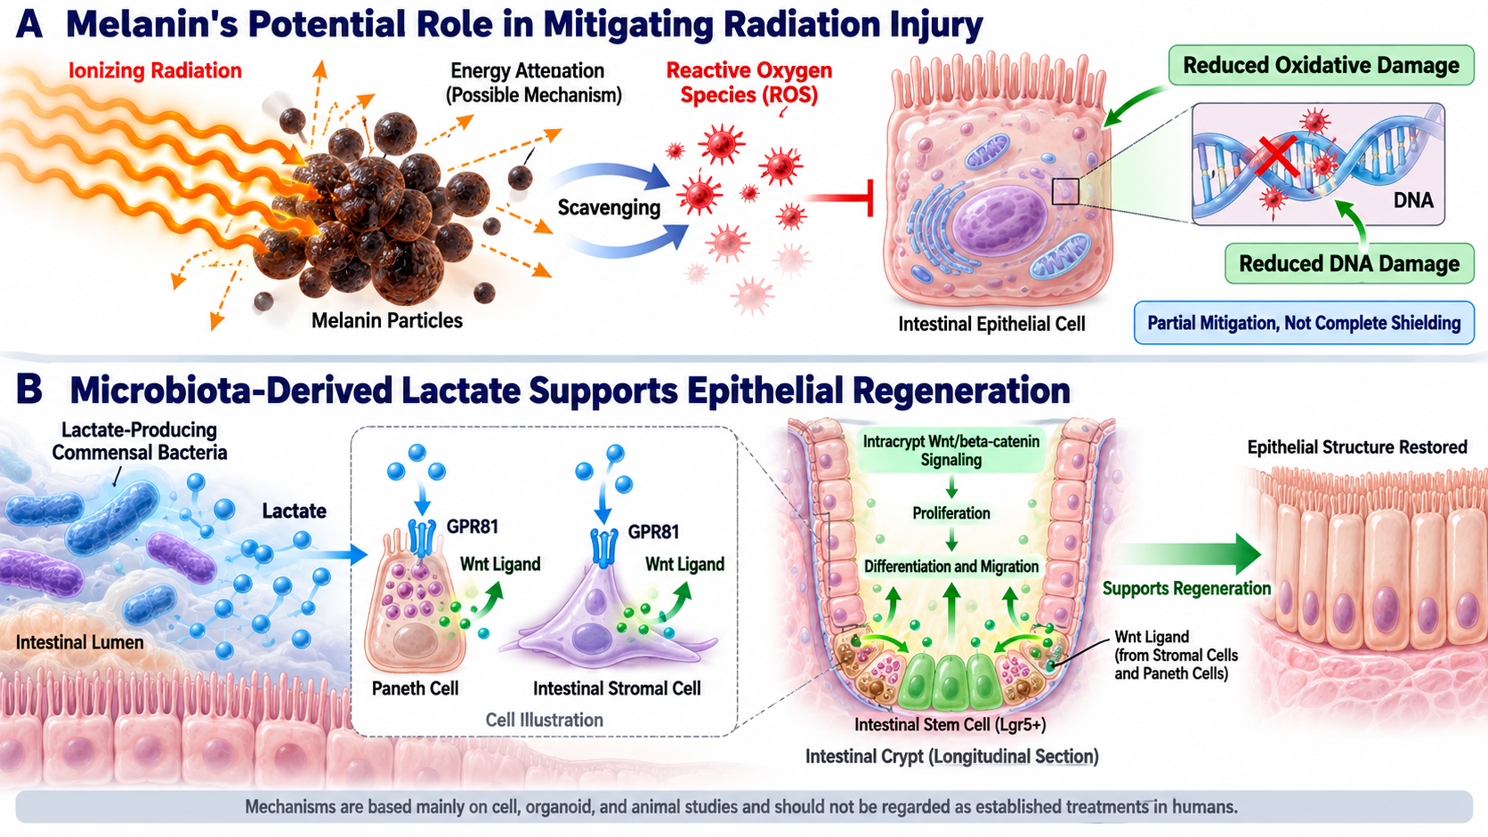
Figure 2. Proposed mechanisms of melanin-mediated radiation mitigation and lactate-supported intestinal repair. Top: melanin particles may reduce injury to cells and DNA by absorbing or scattering part of the incident energy and scavenging reactive oxygen species. Bottom: lactate produced by Paneth cells or intestinal commensal bacteria acts on GPR81, promotes Wnt signaling, and activates crypt stem-cell proliferation, ultimately helping restore epithelial structure. These pathways are supported primarily by experimental research and should not be interpreted as established treatments in humans.

Lactate-supported repair does not mean that more lactate is always better. Lactate production, use, and clearance must remain balanced. In severe hypoxia, infection, or circulatory failure, elevated blood lactate can indicate inadequate tissue perfusion. Patients with short-bowel syndrome or severe carbohydrate malabsorption may also develop D-lactic acidosis when intestinal bacteria produce D-lactate, causing confusion, slurred speech, and abnormal gait [11]. In people receiving cancer radiotherapy or chemotherapy, unsupervised use of lactate preparations or probiotics could interfere with treatment, increase infection risk, or have uncertain effects on tumor metabolism. Animal findings therefore do not justify self-administration of lactate, lactic-acid bacteria, or products marketed for intestinal repair.

4 Scientific Protection and Future Directions

The core of radiation protection remains the reduction of unnecessary exposure. When the ultraviolet index is high, people should limit outdoor time around midday, seek shade, wear protective clothing and a wide-brimmed hat, use appropriate sunglasses, and apply broad-spectrum sunscreen to exposed skin. Darker skin or an existing tan does not eliminate the need for sun protection [1].

In medicine, appropriate use of radiation requires balancing diagnostic or therapeutic benefit against potential risk. X-rays, computed tomography, and nuclear-medicine examinations can provide information that other methods cannot replace. The goal is not to avoid every examination, but to prevent unnecessary repetition and to tell the clinician about possible pregnancy, prior images, and recent related examinations. Radiotherapy uses higher doses to target tumors precisely; effects on normal tissue must be evaluated by the radiation-oncology team according to the treatment field, total dose, and fractionation schedule. Patients should not self-administer high doses of antioxidants, probiotics, or metabolic supplements because they may interfere with treatment or interact with other medicines.

For external exposure to X-rays, gamma rays, and similar radiation, the basic principles are to shorten exposure time, increase distance from the source, and use shielding matched to the radiation type and energy. Medical imaging and radiotherapy should be dose-optimized when there is a clear clinical benefit. Necessary examinations should not be refused because of exaggerated fear, and food or supplements cannot cancel radiation exposure. After suspected accidental high-dose exposure, move away from the source promptly and follow professional instructions for decontamination and medical evaluation. Do not take potassium iodide on your own: it is useful only for specific exposures to radioactive iodine and should be used under the direction of public-health authorities or a physician [2].

Exposure to radiation should also be distinguished from radioactive contamination. External irradiation stops when the source is turned off or sufficient distance is created. Contamination means that radioactive material is deposited on the skin or clothing, or enters the body through inhalation or ingestion. Protection from external irradiation emphasizes time, distance, and shielding; contamination additionally requires removal of the radioactive material. During a public radiation emergency, follow government and emergency-management instructions on sheltering, evacuation, or decontamination. Do not rely on online rumors or self-administer iodine tincture, iodine-rich foods, or so-called detox products.

Supportive care is essential when gastrointestinal symptoms have already appeared. Persistent vomiting and diarrhea can cause dehydration and electrolyte disturbances and require medical assessment and appropriate fluid replacement. Severe bone-marrow suppression increases the risks of infection and bleeding and may require protective isolation, anti-infective treatment, and hematopoietic support. Nutrition should be tailored to the degree of mucosal injury, absorptive capacity, and the patient's overall condition. Discussion of experimental melanin or lactate mechanisms cannot replace standard care such as blood-cell monitoring, correction of fluid and electrolyte imbalance, and infection control.

From a research perspective, melanin and lactate represent complementary strategies. Melanin is aimed more at reducing energy deposition and oxidative attack before injury occurs, whereas lactate may support stem-cell recovery through metabolism and signaling after injury. Their translation to clinical use will require answers about material purity, route of administration, optimal dose, timing, safety, and tumor-related risk, followed by rigorous human clinical trials.

Future research must pass at least three major tests. The first is reproducibility: can different laboratories, animal models, and radiation types produce consistent results? The second is controllability: can protection or repair be directed accurately to normal tissue without compromising cancer treatment? The third is clinical relevance: does the intervention improve diarrhea, infection, length of hospital stay, and quality of life rather than only a few molecular markers? Only after these questions are resolved can an intriguing laboratory mechanism become a reliable clinical tool.

In summary, radiation hazards depend on radiation type, dose, and mode of exposure and cannot be judged without context. Melanin provides natural photoprotection and shows experimental potential to mitigate ionizing-radiation injury. Lactate may promote intestinal stem-cell-mediated epithelial repair through metabolic support and GPR81-Wnt signaling. Melanin is not a natural lead apron, however, and lactate is not a radioprotective medicine that can be taken at will. Until these findings are translated into validated clinical strategies, standard radiation protection, justified medical exposure, and professional treatment remain the most reliable ways to protect health.

References

[1] World Health Organization. Radiation: The known health effects of ultraviolet radiation[EB/OL]. 2024. https://www.who.int/news-room/questions-and-answers/item/radiation-the-known-health-effects-of-ultraviolet-radiation.

[2] World Health Organization. Ionizing radiation and health effects[EB/OL]. 2023. https://www.who.int/news-room/fact-sheets/detail/ionizing-radiation-and-health-effects.

[3] Rodríguez-Colman MJ, Schewe M, Meerlo M, et al. Interplay between metabolic identities in the intestinal crypt supports stem cell function[J]. Nature, 2017, 543(7645): 424-427. doi:10.1038/nature21673.

[4] Centers for Disease Control and Prevention. Acute Radiation Syndrome: Information for Clinicians[EB/OL]. https://www.cdc.gov/radiation-emergencies/hcp/clinical-guidance/ars.html.

[5] Pacelli C, Bryan RA, Onofri S, et al. Melanin is effective in protecting fast and slow growing fungi from various types of ionizing radiation[J]. Environmental Microbiology, 2017, 19(4): 1612-1624. doi:10.1111/1462-2920.13681.

[6] Dadachova E, Bryan RA, Howell RC, et al. The radioprotective properties of fungal melanin are a function of its chemical composition, stable radical presence and spatial arrangement[J]. Pigment Cell & Melanoma Research, 2008, 21(2): 192-199. doi:10.1111/j.1755-148X.2007.00430.x.

[7] Revskaya E, Chu P, Howell RC, et al. Compton scattering by internal shields based on melanin-containing mushrooms provides protection of gastrointestinal tract from ionizing radiation[J]. Cancer Biotherapy & Radiopharmaceuticals, 2012, 27(9): 570-576. doi:10.1089/cbr.2012.1318.

[8] Cordero RJB, Robert V, Cardinali G, et al. A biomimetic approach to shielding from ionizing radiation: The case of melanized fungi[J]. PLoS ONE, 2020, 15(4): e0229921. doi:10.1371/journal.pone.0229921.

[9] Lee YS, Kim TY, Kim Y, et al. Microbiota-derived lactate accelerates intestinal stem-cell-mediated epithelial development[J]. Cell Host & Microbe, 2018, 24(6): 833-846.e6. doi:10.1016/j.chom.2018.11.002.

[10] Okada T, Fukuda S, Hase K, et al. Microbiota-derived lactate accelerates colon epithelial cell turnover in starvation-refed mice[J]. Nature Communications, 2013, 4: 1654. doi:10.1038/ncomms2668.

[11] Bianchetti DGAM, Amelio GS, Lava SAG, et al. D-lactic acidosis in humans: systematic literature review[J]. Pediatric Nephrology, 2018, 33(4): 673-681. doi:10.1007/s00467-017-3844-8.

